
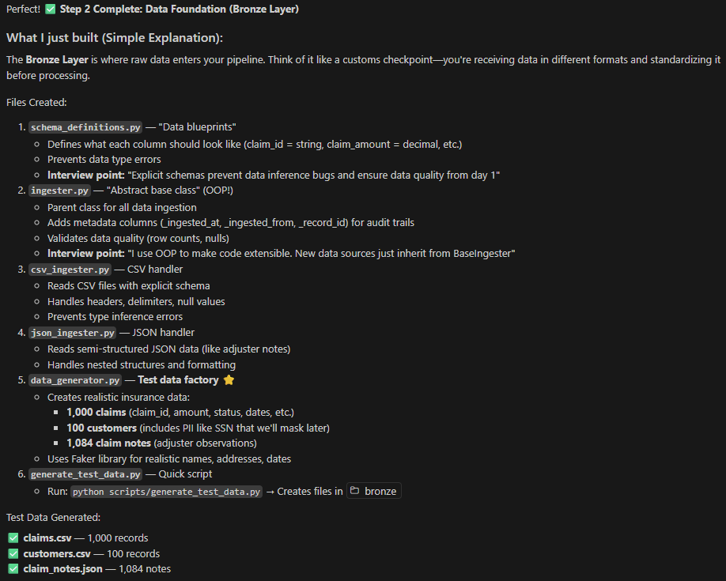


ACID:
Atomicity: The "all-or-nothing" rule. Either every operation in the transaction succeeds, or the entire transaction fails and is rolled back. No partial updates are ever saved.
Consistency: A transaction must move the database from one valid state to another, strictly following all predefined rules and constraints (e.g., ensuring a bank balance never goes below zero).
Isolation: Concurrent transactions (happening at the same time) should not interfere with each other. The database ensures that the final result is the same as if the transactions were executed one after another.
Durability: Once a transaction is committed (finished successfully), its changes are permanent and will survive even a system crash or power failure by being saved to non-volatile storage


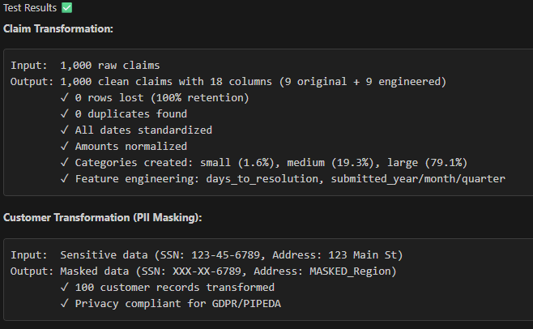
Mask PII is a directive to hide or transform Personally Identifiable Information (PII) so that individuals cannot be directly identified, while still keeping the data useful for analysis or testing.
The General Data Protection Regulation (GDPR) is the European Union's strict privacy law.
The Personal Information Protection and Electronic Documents Act (PIPEDA) is Canada’s federal private-sector privacy law.


